AUTO INTENSITY CONTROL OF STREET LIGHTS

ABSTRACT

White Light Emitting Diodes (LED) replaces HID lamps in street lighting system to include dimming feature. A microcontroller of PIC family is used to control the intensity by developing pulse width modulated signals that drives a MOSFET to switch the LEDs according to achieve desired operation.
In the present system, mostly the lightning up of highways is done through High Intensity Discharge lamps (HID), whose energy consumption is high. Its intensity cannot be controlled according to the requirement so there is a need to switch on to an alternative method of lightning system i.e., by using LEDs. This system is build to overcome the present day drawbacks of HID lamps. This system demonstrates the usage of the LED’s (light emitting diodes) as the light source and its variable intensity control, according to the requirement. LED’s consume less power and its life time is more, as compared to the conventional HID lamps. The more important and interesting feature is its intensity can be controlled according to the requirement during non peak hours which is not feasible in HID lamps.
A cluster of LEDs are used to form a street light. The microcontroller contains programmable instructions which controls the intensity of lights based on the PWM (Pulse width modulation) signals generated. The intensity of lights are kept high during the peak hours, as the traffic on the roads tend to decrease slowly in the late nights, the intensity also decreases progressively till morning. Final it completely shuts down at morning 6, and again resumes at 6pm in the evening. The process is repeated.
This concept in future can be enhanced by integrating it with the solar panel, which converts the solar intensity into corresponding voltage, and this energy is used to feed up the highway lights.
BLOCK DIAGRAM
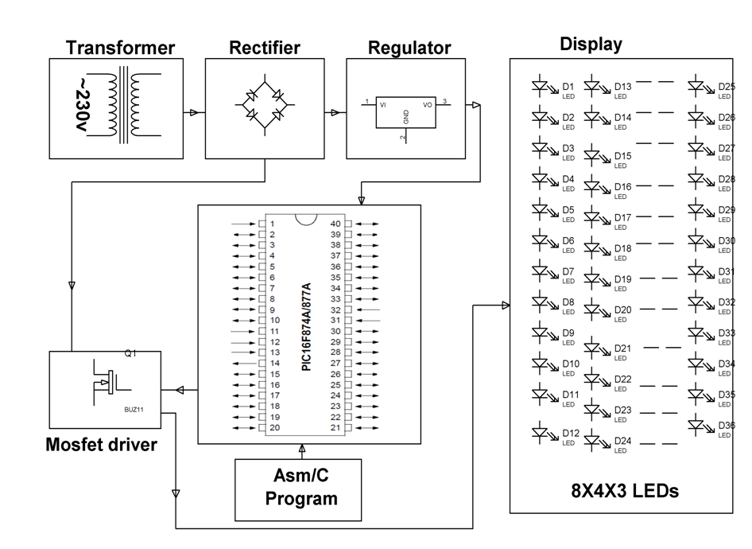
HARDWARE REQUIREMENTS:
Transformer, Diodes, Capacitors, Resistors, LEDs, PIC series Microcontroller, White LEDs, Mosfet, Crystal.
SOFTWARE REQUIREMENTS:
Hi-TECH PICC Toolsuite

Language: Embedded C or Assembly.

